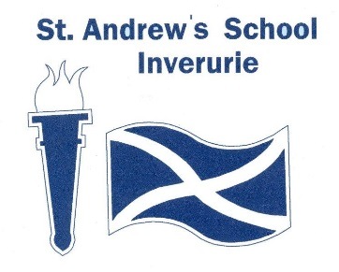
MINUTE – Pupil Council – 21.04.22
Present: Miss Mac, Finlay, Lily, Ryan, Liam, Marcel, Jack, Alfie, Miss Smith, Kelly, Jane
Apologies: Miss Kennedy, Beth, Zak, Karibo, Ryan, James

Item | Discussion | Action by
Welcome | Everyone introduced themselves
Renaming classrooms for next year | Introduced 4 themes – beaches, local castles, Scottish animals, gemstones.  All reps got to experience the sensory element of the themes.  Jack suggested a vote as it was the best way to ask the rest of the school. All agreed, apart from one pupil. Miss Mac suggested talking mats and everyone agreed this was a good idea.  Decision was made to ask all staff members too. Jack suggested email and Miss Mac spoke about Microsoft forms. Everyone agreed this was a good idea and we made a form to send to all staff members.  Kelly asked what would happen if her choice was not chosen and we discussed that this happens when voting. | Talking mat forms given to reps. Talking mats to be returned ASAP.  Miss Mac to email Microsoft form to all staff.
Next meeting | TBC

