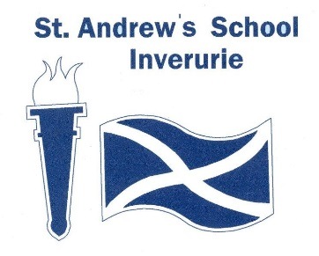

MINUTE – **Pupil Council**

Present: Miss Mac, Beth, Ryan L, Lily, Liam, Marcel, Jack Mc, Miss Smith, Kelly J Julie , Mr Neish

Apologies: Miss Kennedy, Karibo, Zak, Ryan S, Finlay, James W, Alfie

|  |  |  |
| --- | --- | --- |
| **Item** | **Discussion** | **Action by** |
| Welcome | Everyone introduced themselves |  |
| Renaming classrooms for next year | Recapped on what had been happening – the four themes, the individual pupil voting sheets and staff Microsoft Forms.  Members counted the votes. Jack Mc responsible for adding up the totals using his calculator.  The results were as follows:  Castles – 47  Animals – 31  Beaches - 17  Gems – 15  Castles was the overall favourite.  A vote was held with the committee members to whether they wanted Aberdeenshire castles or Scottish castles – 4 votes to Aberdeenshire castles and 1 to Scottish castles.  The whole committee made Aberdeenshire castle suggestions – a total of 13 suggested.  Miss Smith nominated Jack Mc to find the 12 castles closest to the school. | Jack Mc to use Aberdeenshire Castles map to find the 12 closest. |
| AOCB |  |  |
| Closing | Thanks, given to members and staff for their hard work. |  |
| Next meeting | TBC |  |