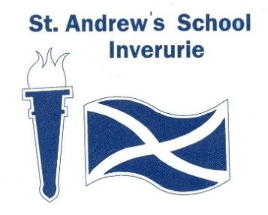

Religious & Moral Education and Religious Observance Policy

Date: February 2023 Review Date: February 2026

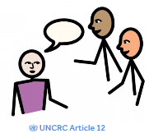
Article 12 – I have the right to be listened to and taken seriously

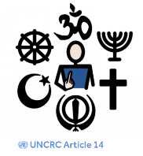
Article 14 – I have the right to have my own thoughts and beliefs
and to choose my religion with my parents’ guidance

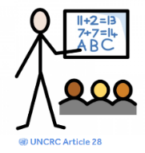
Article 28 – I have a right to a good quality education. I should be
encouraged to go to school to the highest level I can.

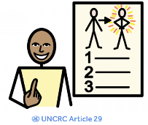
Article 29 - I have the right to an education which develops my
personality, respect for others’ rights and the environment.
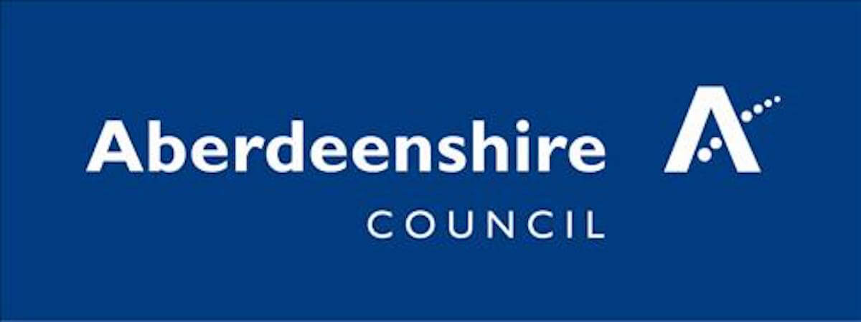

Rationale
The provision of religious and moral education is statutory for all pupils attending non-denominational primary and secondary schools.
“Children and young people deserve the opportunity to have this taught in a meaningful and progressive way.”
Scottish Government Advice Letter, February, 2011

If children and young people are to achieve their full potential and enjoy fulfilment as well-balanced, socially aware individuals, they must consider and express their own beliefs, values and opinions. They must be able to make judgements about what is right and wrong and develop responsible attitudes. Furthermore, to enable them to participate fully in society, pupils need to be educated about the beliefs and values of others. As a Rights Respecting School, we believe, “Children have the right to think and believe what they want and to practise their religion, as long as they are not stopping other people from enjoying their rights.”
United Nations’ Convention on the Rights of the Child, Article 14.

At St Andrew’s School, we recognise that there are a wide range of beliefs across Scotland. These include all world religions and beliefs which lie outwith religion. Diversity of this kind serves as an enriching context in which our pupils can develop their own beliefs and values. Through Religious and Moral Education, our pupils explore the world’s major religions and views which are independent of religious beliefs.
Religious and Moral Education helps pupils develop and reflect on their values and their ability to judge right from wrong. It is our intention to develop in our pupils, responsible attitudes towards other people, regardless of race, religion or beliefs.

Aims
The aims of teaching and learning within Religious and Moral Education will be to:
• recognise religion as an important expression of human experience for some
• learn about and from the beliefs, values, practices and traditions of Christianity and the World Religions selected for study
• learn about other traditions and viewpoints independent of religious belief
• explore religions, recognising the place of Christianity in the Scottish context
• recognise religious diversity and the importance of religion in society
• develop respect for others and an understanding of beliefs and practices which are different from their own
• explore and establish values such as wisdom, justice, compassion and integrity
• develop their beliefs, attitudes, values, and practices through exploration and discovery
• establish a firm foundation for lifelong learning, further learning and adult life.
Religious and Moral Education: Principles and Practices, 2009

The Curriculum Content
Every child can expect their education to provide them with a broad general education, and within Religious and Moral Education, this includes well planned activities for Early, First and Second Level Experiences and Outcomes across Christianity, World Religions and Developing Beliefs and Values. Senior pupils will access a range of SQA National 1 and 2 units that explore World Religions, beliefs and festivals.
Through Rights Respecting Schools, we celebrate a number of religious days and cultural events celebrated in both Scotland and beyond (UNCRC Article 14 and Article 30)

Learning and Teaching Approaches
Teachers are expected to identify appropriate learning and teaching styles to suit the individual and additional needs of their pupils while recognising the importance of active learning and the capacities of Curriculum for Excellence. Due to the additional needs of the pupils at St Andrew’s, learning will include the use of sensory approaches, sensory stories and activities to explore aspects of religion.
Assessment
“Assessment in religious and moral education will focus on learner’s knowledge and understanding of religious practices and traditions and on their skills in making informed, mature decisions to issues of belief and mortality.”
Religious and Moral Education: Principles and Practices, 2009
Approaches to assessment will respect the fact that there is not always a “right answer” when discussing beliefs and values and that, while the process and skills used to come to conclusions can be assessed, an individual’s values and opinions should not be assessed as right or wrong. Similarly, a pupil’s religious faith will never be assessed. Assessment will be linked to the individual needs of the pupil and may link to other curricular areas, both within and outside of the classroom setting. Assessment will be against the school’s levels of engagement.

Recording and Reporting
In determining progress, teachers will establish if a pupil has demonstrated competence in the skills, attributes, knowledge and understanding described in the RME experiences and outcomes. Reporting procedures are in line with Aberdeenshire Council’s policy.
Evidence of pupil work is retained in pupil profiles.

The Role of Parents/Carers
Some parents/carers may have anxieties that RME conflicts with their family beliefs or religious practices. Should this arise, discussion will take place between parents/carers and the Head Teacher so that the educational rationale can be discussed and any anxieties allayed.

Review
This policy will be regularly reviewed and updated every 3 years by St Andrew’s School Senior Leadership Team.

Written: February 2023 Review Date: February 2026

