Autism Policy

Date: Oct 2021 Reviewed: Oct 2022
Review Date: Oct 2023
Article 3 – Adults must do what is in my best interest

Article 12 – I have the right to be listened to and taken seriously

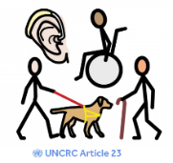
Article 23 – If I have a disability, I have the right to special care and
education

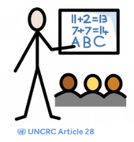
Article 28 – I have a right to a good quality education. I should be
encouraged to go to school to the highest level I can.

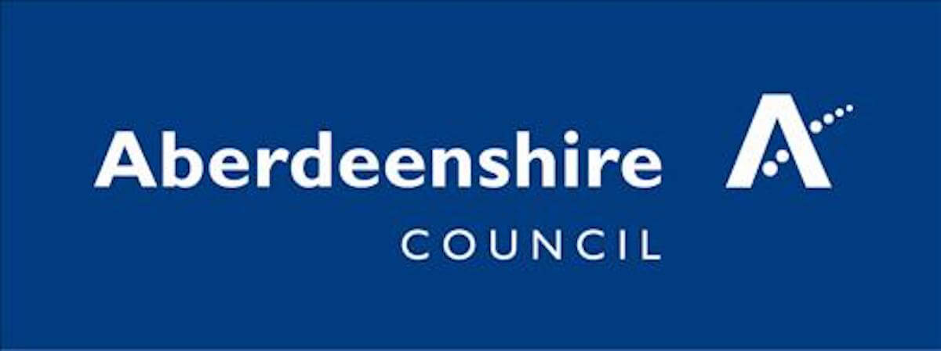

About Our School
St Andrew’s School is a special school for pupils aged 3-18. The school has developed an inclusive approach to accessing learning to enable our pupils to overcome a range of barriers to learning. Many of our learners have autism spectrum conditions (ASCs).
We take the time to build up a deep understanding of each young person, taking into account their processing and thinking style in order to maximise their learning potential. We aim to build and maintain positive, nurturing and accepting relationships with all those who work, and are involved with, the autistic pupil and our dedicated team are equipped with the knowledge and skills to enable each child and young person to have positive life experiences.
Education Scotland’s Getting it Right for Every Child (Scottish Government 2014) and the wellbeing indicators SHANARRI (Safe, Healthy, Achieving, Nurtured, Active, Respected, Responsible and Included) are at the core of our learning. These wellbeing indicators help make it easier for children and families and the people working with them to discuss how a child or young person is doing at any point in time and if there is a need for support.
At St Andrew’s School, we have excellent links with families and value the detailed knowledge parents can provide about their children. We meet regularly with parents and carers with the aim of developing a consistent management approach across both school and home settings. We use strategies such as a home/school diary; photographs, social stories and the ‘2 build a profile’ reports to link home and school and make experiences more meaningful for our learners.
Outreach
St Andrew’s School as part of the Community Resource Hub offers an Outreach service that provides early intervention and support for children and young people aged 3-18 with additional support needs in nurseries and schools.
The Outreach team include a range of staff with expertise in supporting learners who have a range of needs including complex health needs, sensory impairment, behaviour, and autism spectrum conditions (ASC).
The team work with schools, children and families in a range of ways:
- consultation on resources and methodologies
- staff development for individuals and groups
- co-ordination of interventions to raise attainment
- specialist services to support individual needs
- Advice (and when available) direct specialist teaching of areas of the curriculum.

Our approach to supporting behaviours of concern in autism
We use approaches to understand a person’s behaviour, rather than just describe it, recognising the possible impact of differences associated with autism, and how these uniquely impact on the person. We aim to improve the person’s experience and quality of life through use of pro-active approaches to support a feeling of well-being and to reduce the risk of an incident occurring.
What is Autism

Autism is a lifelong neuro-developmental difference in brain development that has a marked effect on how a person develops. Autism affects the way a person communicates and interacts with others, how information is processed and how the person makes sense of the world. Within the autistic population there is also a great deal of diversity and autism manifests differently from person to person.

For children and young people, there is a reciprocal relationship between the autistic learner and the environment - this includes the physical environment and the people around them. With appropriate understanding and adjustments autistic people can flourish.
Children with ASC may have restricted, repetitive patterns of behaviour, interests and activities and significant impairment in social, occupational and other aspects of functioning. The diagnosis of Autism Spectrum Disorder includes being under or over reactive to sensory input or having unusual interests in sensory aspects of the environment. This means that an autistic person is likely to process and respond to sensory information differently to other people.
Children with AS (Asperger’s Syndrome) have neither cognitive impairment nor clinically significant delay in language development but may have significant issues with the understanding, processing and use of social language thus markedly affecting social interaction. They Asperger syndrome comes under the diagnosis of autism and is beginning to be a term no longer used.
Autism often co-occurs with other neuro-developmental differences including:
- Attention Deficit Hyperactivity Disorder (ADHD)
- Developmental Co-ordination Disorder (DCD) also referred to as Dyspraxia
- Developmental Language Disorder (DLD)
- Epilepsy
- Foetal Alcohol Spectrum Disorder
- Intellectual Disability
- Tourette’s and Tic disorders
- Specific Learning Disorder/ Differences e.g. Dyslexia, Dyscalculia
It is important to remember that these definitions are general and that at St Andrew’s School, we acknowledge and understand that every student has unique, individual learning needs that we aim to support and nurture.
The Aim of St Andrew’s School is to Provide:
- An autism specific environment that meets the needs of all pupils.
- A personalised, holistic and dynamic education for all our pupils based on sound knowledge of autism and understanding of each pupils’ needs.
- An environment that supports our pupils to develop independence, social and emotional wellbeing and academic skills.
- An environment that equips our pupils with the required skills and knowledge for adulthood.
Our Environment
St Andrew’s School autistic specific environment consists of four different elements:
- The Sensory Environment
- The Physical Environment
- The Symbolic Environment
- The Social Environment
Our sensory environment takes into account each individual pupil’s sensory needs. These are detailed within our Pupil Information Folders. We provide a range of specialist equipment (if appropriate), use agreed sensory strategies and implement recommendations from our allied health professionals and support agencies. Our school building provides a range of specialised sensory environments including total immersion room, interactive sensory room, relaxation room, sensory integration room, rebound therapy room, dark room, soft play room, several safe spaces and sensory garden.
Our physical environment provides a clear structure for pupils to learn in. Our class sizes are small and specialised, taking into account individual needs. There is uniformity throughout our classrooms, which have sound proofing panels and dimmable lighting. Corridors are wide, spacious and distraction free. The environment aims to be ‘low stimulation’ rather than ‘no stimulation’.
There is a large outdoor area that provides pupils with a range of stimulation such as sensory garden, musical area, playground markings and a playpark with a range of equipment. There are also areas for relaxation and are distraction free.
We follow Aberdeenshire's Total Communication policy. Our symbolic approach consists of using visuals so that pupils are able to understand their environment and feel safe and secure. Should a pupil require a specific individual visual support strategy, then this is provided. We make use of objects, photos, pictures, drawings, symbols, signing and the written word to provide visual support throughout the school in order to support pupils’ communication and understanding.
Our social environment aims to create opportunities for our pupils to communicate and socially interact with each other, adults and people in the wider community. Opportunities to experience new things, share, turn-take and co-operate and participate in a range of experiences in the wider community are built into the school day.

Our Approach

St Andrew’s School does not adopt a single approach to our autistic curriculum but uses a combination of evidence-based strategies and interventions to promote both academic progress, independence, and social and emotional well-being.

SPELL

St Andrew’s School uses SPELL as it recognises the individual and unique needs of each child and emphasises that planning and intervention be organised on this basis. It provides a context for and is complementary to other approaches.

Spell stands for:

- Structure: making somewhere more predictable, safer, and accessible
- Positive approaches and expectations: we seek to establish and reinforce self-confidence and self-esteem by building natural strengths, interests and abilities with expectations high but realistic.
- Empathy: making an effort to understand, respect and relate to an autistic person and see the world from their point of view.
- Low arousal: creating an environment that reduces stress and anxiety and helps aid concentration.
- Links: create and maintain links between the individual, their wider support networks and the community.

TEACCH

We use TEACCH principles to provide structure across all areas of the school. TEACCH also emphasises the importance of identifying underlying strengths and needs related to autism. It is therefore based on understanding the learning characteristics of individuals with autism and the use of visual supports to promote meaning and independence where appropriate.
The TEACCH Autism Program priorities we support are:

- focusing on the person, their skills, interests and needs
- using visual structures to organise the environment and tasks when teaching skills
- being flexible and teaching flexibility.

Total Communication

St Andrew’s School follows Aberdeenshire Council’s Total communication Policy involves. Children with speech and language difficulties or more complex special needs may need support to initiate and take part in communication and interaction. This means making use of all the ways of communication which are available to our pupils.

Speech and spoken language is used alongside other augmentative and alternative communication (AAC) such as: Makaton signing, Photos, Picture symbols, Pictures, Objects, Voice output communication aids and computer based systems, On body signing, Natural gesture, social stories and

Intensive interaction

At St Andrew’s we also use Intensive interaction. Intensive interaction is a play-based approach to helping children develop early, pre-speech communication and interaction skills, like eye contact, facial expressions, the ability to copy sounds, and shared attention. It also aims to reduce repetitive and self-injurious behaviour.

Low Sensory Environment

Our school environment adopts a low sensory approach in learning spaces where appropriate, enabling pupils to access their learning space, and become increasingly independent and self-reliant.

Individual Education Plans & Pupil Information Folders

Each pupil at St Andrew’s has access to a broad and balanced curriculum which follows the national curriculum.

- Aberdeenshire’s Extended Early Curriculum
- Complex needs milestones
- Scottish Broad General Education 3-18 Curriculum for Excellence
- Scottish Qualification Authority Courses
It is important to remember that every child or young person is an individual and shows the autistic aspects of their behaviour and learning uniquely. We feel that it is vital therefore to make sure that we know everything about that individual and use this information when planning rather than relying solely on a general one size fits all approach. St Andrew’s achieves this by creating Individual Education Plans and Pupil Information Folders.

Our Individual Education Plan (IEP) is a comprehensive working document which gives specific guidance on targets relating to wider personal development. The creating, planning, and reviewing of an IEP is a collaborative process involving pupils, parents/carers, school staff and other professionals

The key functions of an IEP are therefore to:
- Detail a child or young person’s additional support needs
- Look at the ways in which a child or young person’s needs will be met
- Describe how learning outcomes will be achieved
- Identify what additional support is required – including that from agencies out with education.

Targets are tracked over the course of a year.

Pupil Information Folders are used to outline information which is useful for staff to enable the autistic person to access their learning. St Andrew’s School recognises that transitions for pupils with ASC can be a difficult time. St Andrew’s School aims to provide the right structure that allows the pupil to understand the transition process and reduce anxiety. Transitions are unfortunately unavoidable as a pupil moves through their education and beyond. We aim to provide the appropriate structure and support whilst building the independence and resilience of the pupil so they can manage further transitions. Pupils are supported with daily transitions using visual timetables, objects of reference and verbal cues.

Training

All staff members will undertake autism specific training during their induction. Supplementary to this, St Andrew’s School offers continuing professional development to all staff during their employment. This includes in-house and external opportunities such as further qualifications through the Post Graduate Certificate in Autism and Learning offered at University of Aberdeen.

Review

This policy should be reviewed annually, in combination with NAS accreditation guidance, current research and legislation. As the school is developing, this policy may be reviewed more often.

Reviewed: October 2022 (Added UNCRC Rights) Review Date: October 2023

