Anti-Bullying Policy
Date Written: Review Date:
Review Date: January 2025
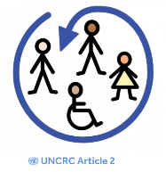
Article 2 – All children have these rights – no discrimination.
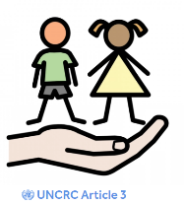
Article 3 – Adults must do what is in my best interest.
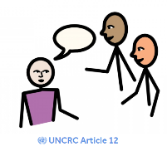
Article 12 – I have the right to be listened to and taken seriously.
Article 19 – I have the right to be protected from being hurt
or badly treated.
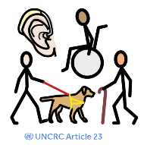
Article 23 – If I have a disability, I have a right to special care
and education
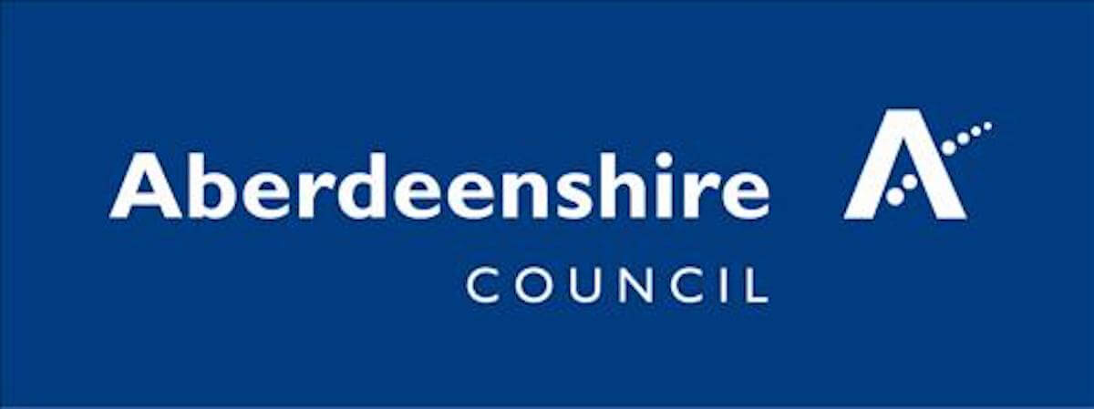

St Andrew’s School Antibullying Policy
Aims:
The aim of the anti-bullying policy is to ensure that pupils learn in a supportive, caring and safe environment, without fear of being bullied (UNCRC Article 19 – I have the right to be protected from being hurt or badly treated). Bullying is anti-social behaviour and affects everyone; it is unacceptable and will not be tolerated. Only when all issues of bullying are addressed will pupils be able to fully benefit from the opportunities available at schools.
Bullying is defined as deliberately hurtful behaviour, repeated over a period of time, where it is difficult for those being bullied to defend themselves. The three main types of bullying are:
• physical (hitting, kicking, theft)
• verbal (name calling, racist remarks)
• indirect (spreading rumours, excluding someone from social groups).

The nature of their learning needs means that pupils with Autism, SLD and PMLD may not have sufficient understanding or awareness that certain behaviours directed towards others may be undesirable or that they might be construed as bullying. Similarly, some pupils at St Andrew’s, who are the recipients of such behaviours may be unable to express or communicate their aversion to such behaviours or to tell adults. This means that all staff at St Andrew’s School have a duty to not only be aware of such behaviours and of any child involved, but also to respond appropriately to instances of bullying behaviours (UNCRC Article 3 - Adults must do what is best for me).
If necessary, St Andrew’s School can draw upon a range of skilled and knowledgeable professionals to help devise strategies to manage and reduce bullying behaviours and their effects. This could be for example enlisting the assistance of SLT for sharing social stories or helping with appropriate symbols (UNCRC Article 23 – If I have a disability, I have the right to special care and education).
Implementation:
The pupils attending St Andrew’s School all have an Individual Education Plan. This may mean that they are likely to have a limited ability to comprehend that they may be engaging in activities which have the characteristics of bullying behaviour. These may include wanting to be near a ‘target’ child or being interested in making physical contact with a pupil, such as touching a particular part of his or her body, or demonstrating potentially physically harmful behaviours, such as kicking or pinching the skin. The pupil who is the target may show fear or anxiety when they see the pupil who targets them. This information must be shared amongst all members of the class team, and also shared with other members of staff as soon as possible, particularly with those on duty during playtimes and lunchtime. Staff need to be skilful in observing the outcomes of the behaviours described above. It is important to refer to pupil documents such as the sensory passport. The proactive strategies being employed to overcome a pupil’s potential or actual bullying behaviour must be recorded in the chronologies of all the involved children. Strategies need to be carried out over a specific time span and their effectiveness reviewed. It is important that strategies are shared with parents and carers of the pupils involved so that there is a consistency of approach at school and at home. It is also important to help the pupil who is the target of bullying behaviour, particularly as he or she may have difficulty communicating about their experiences. The child should be able to communicate in his or her preferred mode (UNCRC Article 12 – I have a right to be listened to and taken seriously). The pupils need to understand that they will always be “safe” if they do this.
Bullying and The St Andrew’s School Curriculum
In all work with pupils, staff emphasise the importance of developing social skills, including respect for the feelings of others. Where pupils have difficulties interacting appropriately with their peers or with adults, then staff aim to help them develop an awareness of why particular behaviours are valued socially and what is inappropriate. The St Andrew’s School curriculum builds on this through a wide range of activities and social learning experiences. Staff are important role models for the pupils. The behaviour of adults towards each other and towards the pupils is a potentially highly effective tool for preventing and for decreasing bullying behaviours in pupils with Autism, SLD and PMLD.
Every member of the school community is entitled to expect equality of protection from bullying as well as protection and support from school policies and procedures designed to ensure that the school remains a safe environment in which to teach, learn and thrive.
As a school, we work together and strive to eliminate discrimination, harassment, victimisation and any other conduct that is prohibited by or under the Equality Act 2010. This also includes promoting equality for people with ‘protected characteristics’. The ‘protected characteristics’ the Act covers as discrimination are based on: age, disability, gender reassignment, marriage and civil partnership, pregnancy and maternity, race, religion or belief, sex and sexual orientation (UNCRC Article 2 – All children have these rights – no discrimination).

It is really important that all children gain an understanding of the world they are growing up in, and learn how to live alongside, and show respect for, a diverse range of people. Where the children do not have the level of understanding to make this possible then it is up to the adults to ensure that St Andrew’s School is free from bullying and intimidation for all pupils, staff and everybody who makes up the school community.
Staff Responsibility
We recognise that all adults in the school are in effect role models for the students. The way in which we behave towards each other and to students is particularly important in terms of providing positive role models. Therefore, as adults we must:
- show respect for every child and other colleagues within the school community as individuals
- be aware of vulnerable pupils
- criticise the behaviour rather than the child
- avoid favouritism
- be seen to be fair
- avoid labelling
- have high expectations of pupils
- never give children ammunition to use against each other
- actively seek to develop a praise culture within the school.
- Ensure that all areas of the school are adequately supervised

Staff and all other adult members of the school community can be victims of bullying. Where this is the case then they should initially speak to the SMT member with whom they feel most comfortable.

